|  |  |
| --- | --- |
| Roll. No. A016 | Name: Varun Khadayate |
| Class B.Tech CsBs | Batch: 1 |
| Date of Experiment: 15-3-2022 | Date of Submission: 15-3-2022 |

# Case Study: Observing a website. Study about its content, structure.

Website Analysed : <https://www.nmims.edu/>

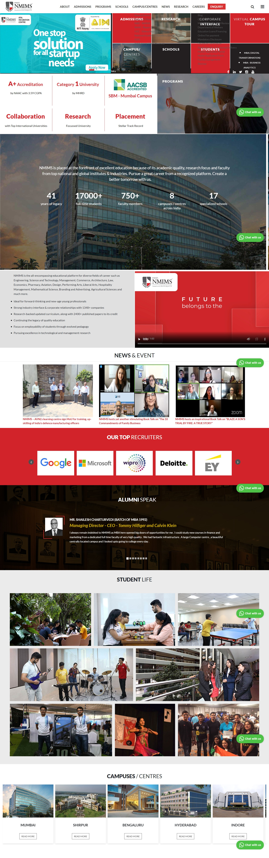 

## Header- the initial part is the header section where on the top left side is the logo and left section includes all the navigation tabs for the website.



1. Below the header is a section which includes grid allocation, which includes the achievements of the university, programs and other things.



## The next header is an image which has its position fixed and above the image is a little description about the University. Along with a video tag used being the position as right.



## The next section has news, events and the recruiters for the NMIMS University. All the image tags have onclick event. So, when the images are clicked, you are redirected to a different website.



## The final section is alumni column which has a carousel which shows different alumni speaking about the university. The student and campus section have parallax effects which are triggered once the user scrolls through that section.



## A common feature is an embedded whatsapp icon at the bottom right corner which when clicks open a chat box of whatsapp.

